Jal Gandhi_1066
Git Assignment-2
Task 1 :
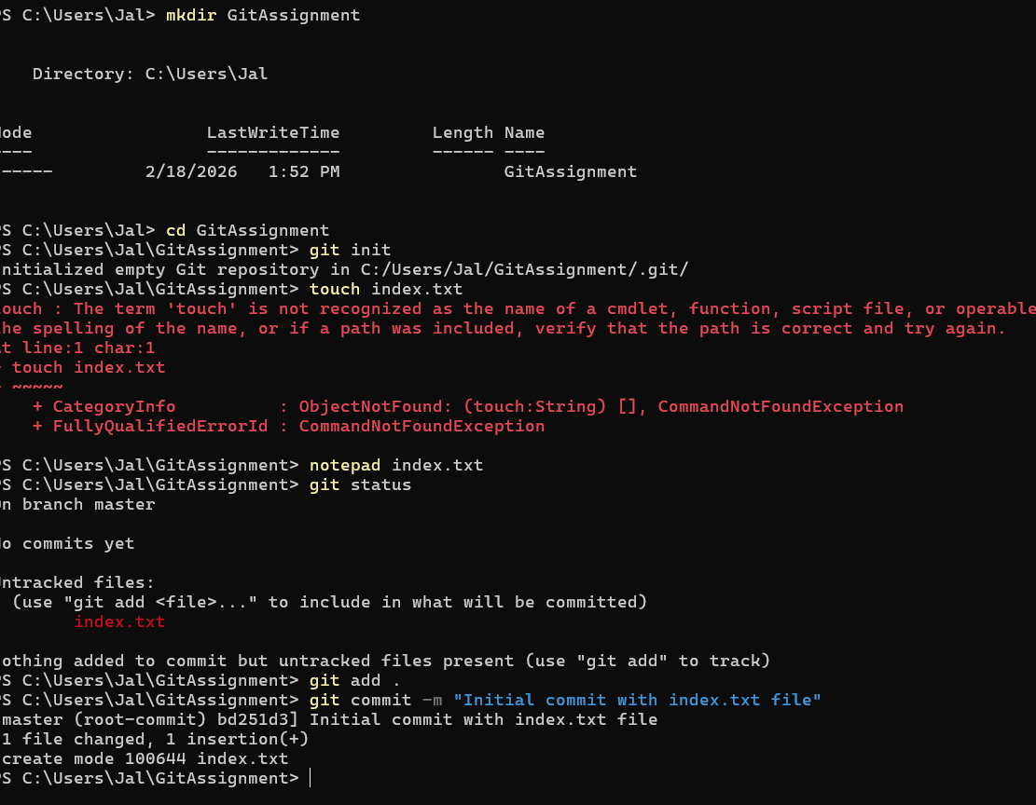
Task 2:
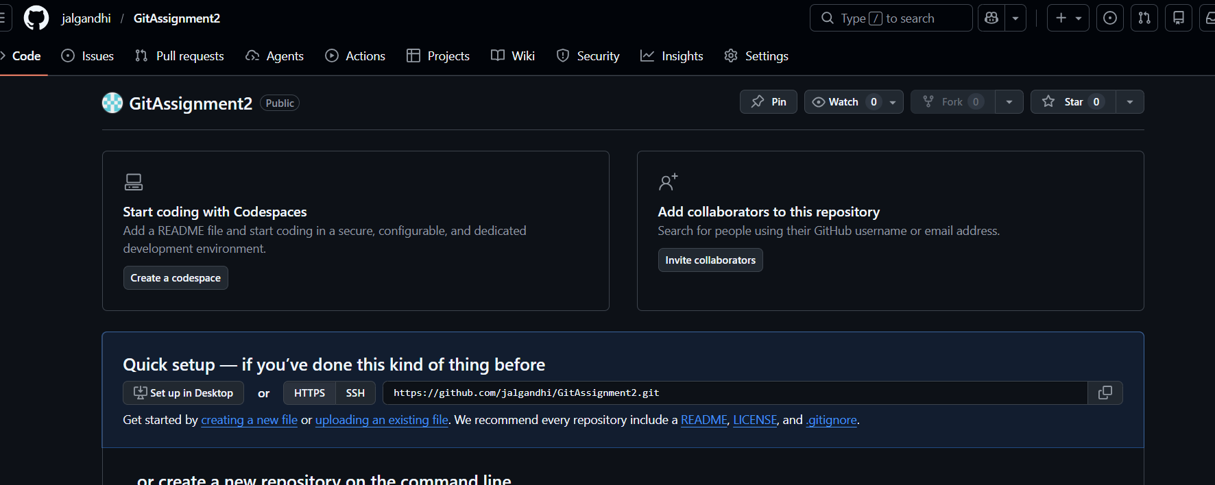

Task 3 : 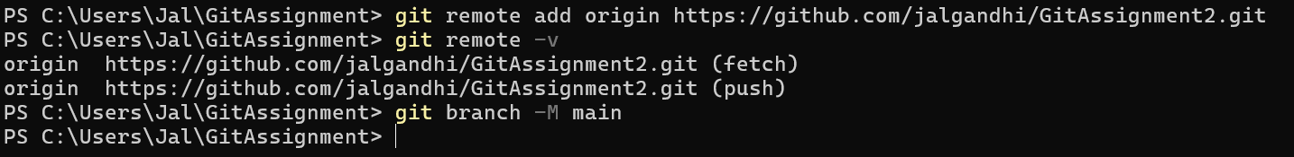
Task 4 : 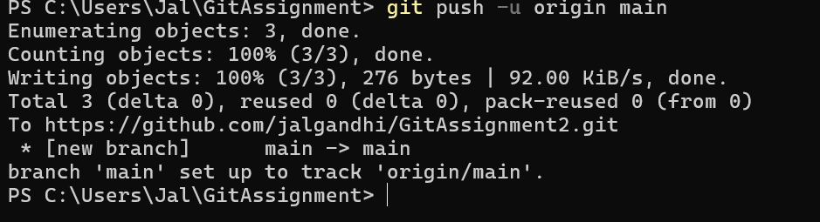
Task 5:
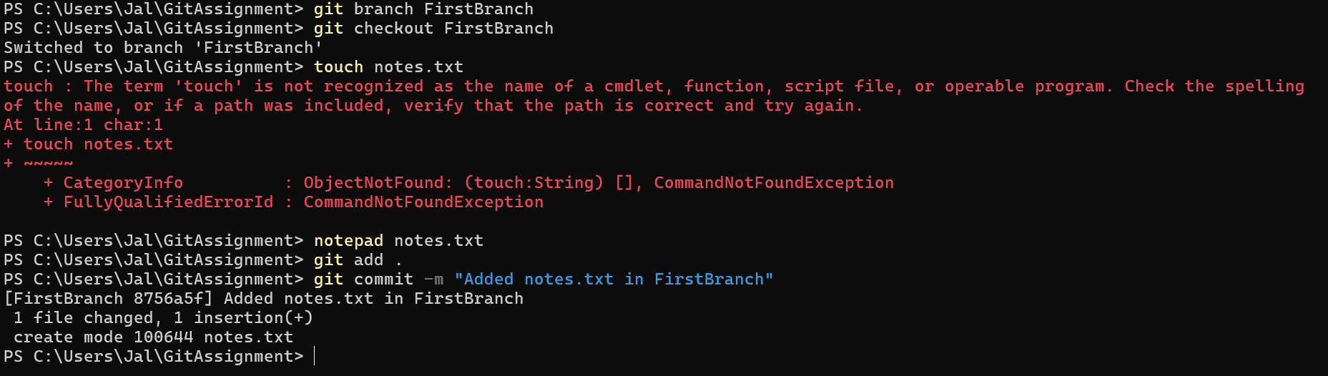

Task 6 :
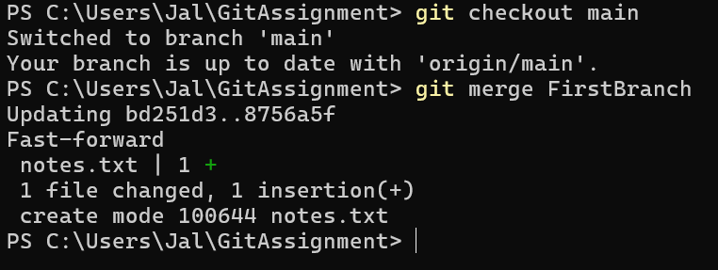
Task 7:
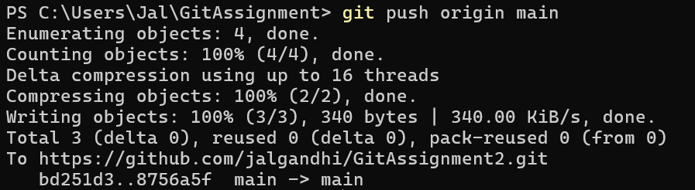

Task 8 :
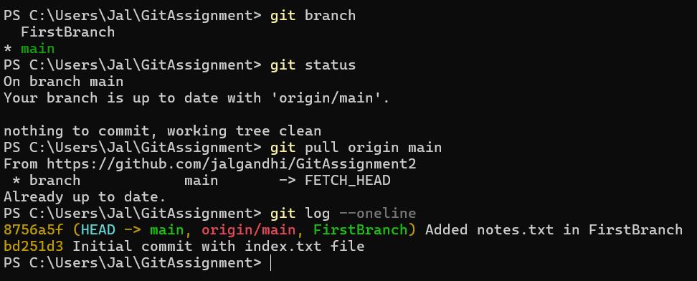
Task 9 :
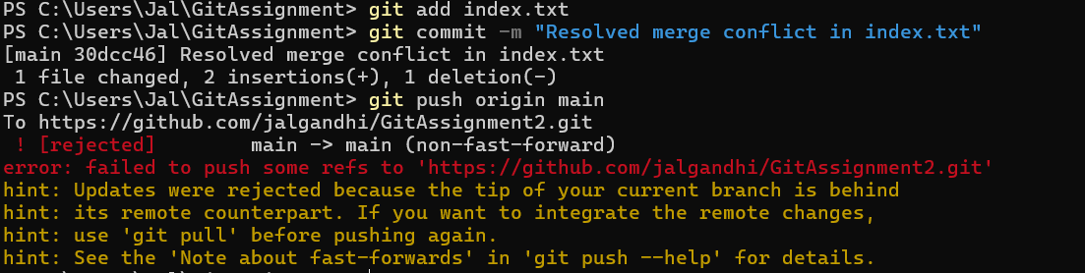
Task 10:
